These are small things but are really important

Also, it cost a lot of time to write these, every time if forgotten

How to remove the last two items of string

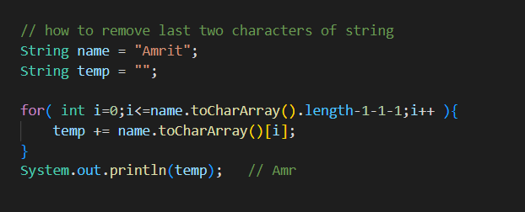

How to sort objects?

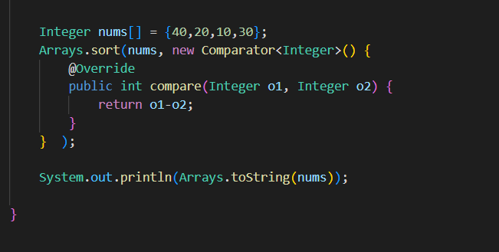

Let say we want to sort in descending order

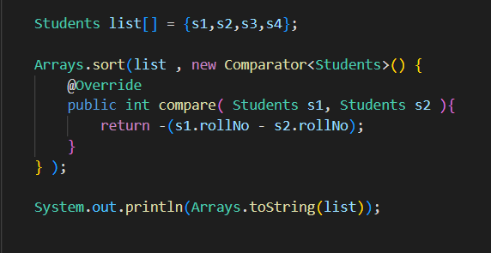

Just add the “-“ while returning

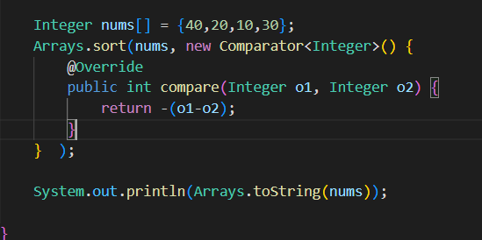

Refer Comparing objects